**Leader Overview**

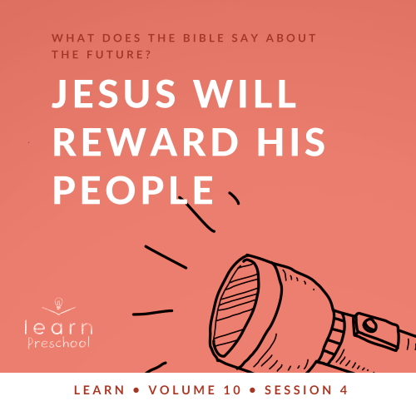

**Volume Overview**

**What does the Bible say about the future?**

*It’s easy to see that our society is obsessed with the future. But what does the Bible say about the future? While it was written thousands of years ago and much of its contents has already taken place, we do get a glimpse of the future in the Bible. We know there is life beyond this life. We know the brokenness and pain in this world will not last forever. We know God will make all things new, and He will right every wrong. For Christians, the future is something we can look forward to.*

**Session Overview**

**Jesus Will Reward His People**

*In this* **Learn** *session, preschoolers will discover that one day Jesus will reward people who are righteous and that He will punish those who have rejected Him. In the parable about the sheep and goats, Jesus described the time when He will sit on His throne and separate people based on their faithfulness to Him. This judgment that Jesus makes will last for eternity. He will reward those who chose to follow Him.*

**Bible Lesson**

Parable of the Sheep and Goats

[Matthew 25:31–46](https://ref.ly/logosref/Bible.Mt25.31-46)

**Faith Fact**

Jesus rewards His people.

**Faith Verse**

[1 Corinthians 2:9](https://ref.ly/logosref/Bible.1Co2.9) (NLT)

“No eye has seen, no ear has heard, and no mind has imagined what God has prepared for those who love him.”

**Preparing for the Session**

**Leader Preparation Time: 20–25 Minutes**

|  |
| --- |
| ***You Will Need***  ***Preservice Activities***  *• Empty box*  *• Wrapping paper*  *• Bow or ribbon*  *• Scissors*  *• Tape*  *• Leader’s choice snack*  *• Toys*  ***Large Group***  *• Bible*  *• Worship songs (Song suggestions: “Praise Goes On” by Elevation Worship Lyric Video; “Ask Seek Knock” by Hillsong Kids; “We Came to Meet with You” by Hillsong Kids)*  *• For groups not using a phone or tablet only, add:*  *• Projector or TV*  *• Laptop*  *•* ***Faith Fact Sound*** *video (bell ringing)*  *•* ***Faith Fact Slide***  *•* ***Faith Verse Slide***  *•* ***Bible Lesson Video A***  *•* ***Bible Lesson Video B***  ***Small Group***  *• Small balls, two per group*  *• Small prizes (Stickers, lollipops, etc.)*  *•* ***Small Group Activity Page****, one per kid*  *• Crayons or markers*  *• Fun songs for kids (Song suggestion: “For Your Glory” by Elevation Church Kids or your choice)*  *• Something to play the music on*  *• Colander*  *• Marbles or shiny coins*  *• Sand or flour*  *• Two large bowls*  *To access session content and videos from a computer, visit:* [***BibleEngagementProject.com/downloads***](https://bibleengagementproject.com/downloads) |
| ***Getting Ready***  ***Preservice Activities***  *• Set out toys and snacks.*  *• Wrap the box to look like a present.*  ***Large Group***  *• Download videos and slides if needed.*  *• Select worship song(s) and have them ready to play.*  ***Small Group***  *• Print copies of the* ***Small Group Activity Page****, one per kid.*  *• Fill one bowl with sand or flour and hide the marbles or coins in the sand so they can’t be seen.*  *First time leading* Learn *for Preschool? Check out the* [***Facilitator Guide***](https://0b769b0ed3569ef9d18b-f88d8272f61086866d50d048b43ef630.ssl.cf2.rackcdn.com/sites/biblengagementproject/Listen_Facilitator_Guide.pdf)*.* |

**Preservice Activities**

*See what’s needed at the beginning of the session.*

**Bible Story Warm-Up**

*(Hold up present.)* Do you like getting presents? *(Group response)* I love to get presents, and I love to give presents. It’s exciting to watch people I love get something that I made or bought for them. It makes me so happy on the inside.

What’s the best present you’ve ever received?

Who gives you the best gifts?

What’s the best gift you’ve given to someone?

Those were some really great answers. This box that I’ve been holding looks really pretty. Holding it makes me excited because somebody took the time to wrap it just for me. Today, we’ll learn that Jesus is preparing something special for you and me and all those who have chosen to follow Him. The things that Jesus gives us are so much better than anything anyone else could ever give to us.

**Snack**

**Leader’s Choice**

*As kids are eating the snack, share the following:*

Have you ever played the game Follow the Leader? *(Group response)* If you haven’t, it’s a pretty easy game. You form a line with your friends and follow the person at the front. If the leader jumps, everyone jumps. If the leader runs, everyone runs. Wherever the leader goes and whatever the leader does, everyone should follow them exactly. We have the chance to follow Jesus, and when we do, we get to experience all the good things or blessings He has for us.

What are some ways we can follow Jesus? *(Loving Him, loving others, worshipping, etc.)*

Why do you think Jesus wants us to follow Him? *(He wants to spend time with us now and forever.)*

How can we help others follow Jesus? *(Tell them that He loves them.)*

**Free Play**

*Any extra time can be spent playing with toys.*

**Transition**

*A few minutes before service begins have kids make their way to the large group area and sit in their designated areas.*

**Large Group**

**25 Minutes**

*See what’s needed at the beginning of the session.*

**Introduction**

Hey, my friends! I’m so excited to be here with you. Getting to spend time with you is one of my favorite things. To make things even better, we’ll have so much fun learning about God’s Word. *(Hold up Bible.)* I hope you’re ready to have some fun. If you’re excited to be here, wave your hands in the air. *(Group response)*

Today, we’ll learn about the awesome truth that Jesus has good things for His people. We know that Jesus is coming back soon. He wants us to be ready, He wants us to finish strong, and He wants us to make the right choices. When we do those things, we will be blessed by Him.

**Faith Fact**

As people who follow Jesus, we should do our best to put Him first in our life. We should love and worship Him. The Bible says that everyone who follows Jesus will be blessed and get to spend eternity, that’s forever, with Him. **Jesus rewards His people.** That’s our Faith Fact for today.

Can anyone tell me what a reward is? *(Allow responses.)* You’re right. It’s like a prize for doing good. In our Bible story we’ll find out more about our reward of being with Jesus forever in heaven.

• *Show the* ***Faith Fact Slide.***



Grab your big, loud voice. On the count of three, we’re going to say our Faith Fact as loud as we can! Ready? 1, 2, 3. **Jesus rewards His people.** Woah! That was so loud. Great job! Now, reach down way low *(demonstrate this)* and use the lowest voice you have. Ready? **Jesus rewards His people.** That’s so good!

**Bible Time**

It’s time to learn from the Bible. God’s Word is amazing. It’s filled with stories about people who lived just like you and me. Jesus often told stories in the Bible to help people like us understand more about God’s plan. I can’t wait to learn more with you right now. We’ve got someone special to help us do that. Let’s see what Lizzy is doing.

• *Play* ***Bible Lesson Video A****.*

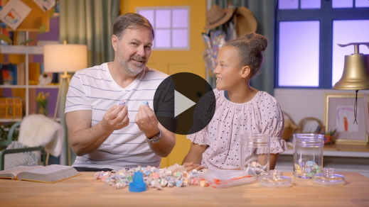

Hey! Do you think you would have tasted the candy that Grandpa and Lizzy didn’t like? *(Group response)* If they didn’t like it, I don’t think I would either. Thanks for helping Lizzy solve all the clues.

As we listened to the Bible story, Jesus told about some sheep and goats. In Bible times, a shepherd had a very important job to take care of the animals. Jesus is our Shepherd. We’re like sheep, except we don’t say, “Baa.” He takes care of us and leads us where we need go. Jesus told us the importance of following Him like sheep because then we can go to heaven. Those who are like the goats don’t follow Jesus and won’t get to go to heaven. This story reminds us that Jesus rewards those who love and follow Him.

**Worship**

When we choose to follow and obey God, we’re showing Him how much we love Him. Another way we can show God how much we love Him is by telling Him through praise and worship. Let’s praise Him now.

**Praise**

Are you glad God is here with us? Jump three times. *(Group response)*

Would you like to thank Jesus for taking care of us? Clap your hands in a circle. *(Group response)*

Who’s ready to worship God and show Him we love Him? Wave your hands up high and turn around one time. *(Group response)*

**Sing**

It’s time to focus our ears, our heart, and our mind on Jesus. As we sing, let’s think about how good He is to us. Maybe you’d like to clap your hands or raise them high. Maybe when you worship you like to move around to the music. You can choose how you worship, but the important thing is to focus on Jesus.

• *Lead the kids in singing one or two songs. See song suggestions at the beginning of the session.*

**Prayer**

That worship was amazing! It’s always so special when we spend time with God, and He loves to spend time with us. Let’s continue to spend time with Him and take a few moments to talk with God.

|  |
| --- |
| Dear God, thank You for the promise of heaven. We love that Jesus is preparing a place for us. Help us to focus on You and to always follow You. We want to spend forever with You. Amen. |

**Bible Time cont’d**

Today has been awesome so far. It’s been so cool to learn more about the Bible with you. It’s even more exciting when we take time not only to read or listen to the Bible but also to memorize God’s Word. Let’s check back in with Lizzy to say our Faith Verse.

• *Play* ***Bible Lesson Video B.***

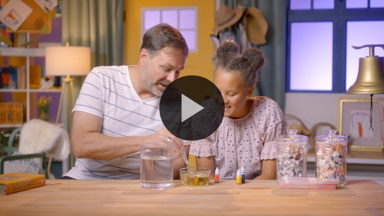

That was stupendous! You’re constantly amazing me by how smart you are. It’s so cool that you’re learning God’s Word. This verse teaches us that God is preparing something special for us that we can’t even imagine. How great is that? *(Group response)* Learning this Bible verse together will help us remember the truth that **Jesus rewards His people.**

In our Bible story today, what happened to the people who showed love to Jesus by taking care of others? *(Allow responses.)* That’s right, they were welcomed into the place Jesus had prepared for them. They loved Jesus and served people the way that He would. The ones who chose not to follow Jesus were sent away. They were separated from Jesus forever. That’s not something you have to be afraid of when you choose to follow Jesus.

**Response Time**

Let’s stop and think about what we’ve learned today. During this time, we’ll ask God how He can help us to faithfully follow Him. *Faithfully* means we try to always follow Him. Let’s pray.

• *Optional: Have the kids repeat phrases of the prayer after you.*

|  |
| --- |
| Dear God, I want to be with You forever. Help me to always follow You so that I can show others the way to You. Help me to love others the way You love me. Thank You for preparing a place for me with You in heaven. I love You. Amen. |

**Faith Verse**

Did you know God loves it when we learn Bible verses from His Word? Let’s say our Faith Verse again and do the actions together.

[1 Corinthians 2:9](https://ref.ly/logosref/Bible.1Co2.9) (NLT)

“No eye has seen, no ear has heard, and no mind has imagined what God has prepared for those who love him.”

• *Show the* ***Faith Verse Slide***.

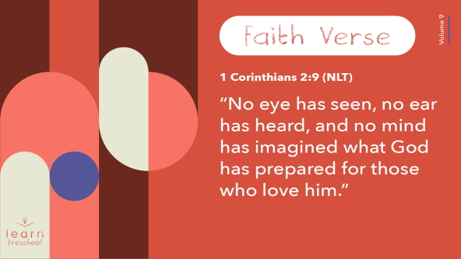

Wow! Everyone has really done well learning our Faith Verse.

**Closing**

Did you have fun learning about God today? *(Group response)* We’ve worshipped Him by singing and praying. We’ve learned a Faith Verse from the Bible. We were reminded that Jesus has gone to prepare a place for us. Soon He’ll be coming back. We know that when He comes back, He will reward those who have chosen to follow and love Him. Why? **Jesus rewards His people.**

• *Play the* ***Faith Fact Sound*** *video (bell ringing).*

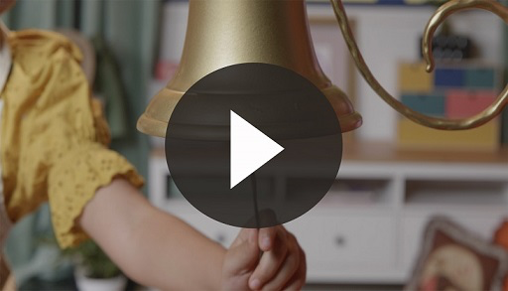

That sound means it’s time to practice our Faith Fact one more time.

• *Show the* ***Faith Fact Slide.***



Let’s say it as loud as we can. Ready? **Jesus rewards His people.** This time let’s whisper it. **Jesus rewards His people.** Let’s shout it again. Ready? **Jesus rewards His people.**

**Dismissal to Small Groups**

Today has been absolutely amazing so far. Let’s keep the fun going as we head to our circles to learn more about Jesus.

• *Dismiss the kids by groups*.

|  |
| --- |
| ***Leader Tip:*** *This can be done by assigning color teams or by age groups. Note that some young preschoolers may not know their age. Using a colored sticker, jersey, or wristband will help separate the kids and help identify their small groups.* |

**Small Group**

**25 Minutes**

*See supplies and prep instructions at beginning of session or in each activity below.*

|  |
| --- |
| ***Leader Tip:*** *Small groups can alternate to each circle, or all groups can do each activity at the same time. If you choose to alternate, you will need at least one leader per circle.* |

**Circle 1**

**Group Connection**

**Pass the Prize**

|  |
| --- |
| ***You Will Need***  *• Small balls, two per group*  *• Small prizes (Stickers, lollipops, etc.)*  *No prep needed for this activity.* |

Wow! I don’t know about you, but I get really excited when I think about my future with Jesus. I can’t wait to get to be with Him in heaven one day. I think it’s amazing that Jesus has promised something special for us. He is always looking for ways to pass His blessings to us. He wants us to pass on His love to other people.

• *Have kids move into a circle.*

To help us remember this, let’s do a speed activity. I have two balls. *(Show the balls.)* I’ll give them to two people and then count to three. When I say, “Three,” you’ll pass the ball as fast you can around the circle. When I say, “Freeze,” everyone stops. *(Give balls to two kids.)* Ready? 1, 2, 3.

• *Stop the game after a short time.*

What do you think will happen to the ones who are holding the balls? *(Allow responses.)* Most of the time when I play games like this and the ball stops with me, I’m out. Remind me what our Faith Fact today is. *(Group response)* **Jesus rewards His people.** That’s what I’ll do. Today, whoever has the ball receives a prize. That’s the same way it will be with Jesus. The ones who choose to live for Him will receive the reward He has planned.

• *Repeat this activity until everyone has a chance to receive a small prize.*

• *During the activity, interrupt and practice the Faith Fact:* **Jesus rewards His people.**

• *Play the* ***Faith Fact Sound*** *video. Review the Faith Fact even if you can’t play the sound.*



**Circle 2**

**Activity Page Time**

**Heaven Welcomes Us**

|  |
| --- |
| ***You Will Need***  *•* ***Small Group Activity Page,*** *one per kid*  *• Crayons or markers*  ***Getting Ready***  *• Print copies of the* ***Small Group Activity Page****, one per kid.* |

If you know today’s Faith Fact, raise your hand. (*Allow responses.)* That’s right! **Jesus rewards His people.** When we choose to follow Jesus, He blesses our life. What does it look like to follow Jesus? *(Allow responses.)* Those are great answers! When we follow Jesus, we ask Him to forgive our sin and ask Him to help us make right choices. We choose to obey Him and follow what it says in the Bible. Then, one day we get to go to the special place He is preparing for us. Do you know what we call that special place where we’ll live with Jesus? *(Allow responses.)*

• *Hand out a copy of the* ***Small Group Activity Page*** *and crayons to each kid.*

That special place is heaven. Jesus wants everyone to choose to live there with Him. Let’s say our Faith Fact together one more time. **Jesus rewards His people.**

**Circle 3**

**Feet-to-Floor Game Time**

**Wiggle and Stop**

|  |
| --- |
| ***You Will Need***  *• Fun songs for kids (Song suggestion: “For Your Glory” by Elevation Church Kids or your choice)*  *• Something to play the music on*  *No prep needed for this activity.* |

Who’s been having fun today? *(Group response)* Who’s ready to have more fun? *(Group response)* I think it’s time we get our feet to moving. Today’s game is pretty simple. It’s called “Wiggle and Stop.” When I say, “Wiggle,” music will start, and you can wiggle and move around. When I say, “Stop,” the music will stop, and you’ll freeze in place. When everyone is frozen still, we’ll say our Faith Fact together. Let’s practice our Faith Fact right now. Ready? **Jesus rewards His people.**

If you’re ready to move, let me hear you say, “Oh yeah!” (*Group response)*

• *Allow kids to play this game for as long as time permits.*

• *Optional: Call on kids to lead the moves or give them instructions to move in a specific way (spin around, hop on one foot, etc.).*

You’re great wigglers. That was epic! Let’s say our Faith Fact one more time before we’re done here. Ready? **Jesus rewards His people.**

**Circle 4**

**Hands-On Learning**

**Sifted Out**

|  |
| --- |
| ***You Will Need***  *• Colander*  *• Marbles or shiny coins*  *• Sand or flour*  *• Two large bowls*  ***Getting Ready***  *• Fill one bowl with sand or flour and hide the marbles or coins in the sand so they can’t be seen.* |

Today, we learned that Jesus will separate people who choose to follow Him from those who choose not to. Remember how Jesus told the Bible story about the sheep and goats that were separated? *(Group response)* Do you remember what happened to those who chose to follow Jesus like the sheep? *(Allow responses.*) They’re able to spend eternity with Him. What about the people who chose not to follow Jesus like the goats. Will they go to heaven? *(Group response)* No, they won’t get that reward or blessing. Their choices caused them to be separated from Jesus.

It’s kind of like this bowl. *(Pick up the bowl and point to colander.)* This is a colander. That’s a crazy word. Can you say it? *(Group response)* Some people call it a strainer. What do you think will happen when I pour what’s in the bowl into the colander? *(Allow responses.)* Let’s find out.

• *Pour sand into colander over empty bowl.*

Wait, there’s something in here! What is it? *(Allow responses.)* Yes! They’re marbles. Some are shiny, and others are bright and colorful. *(Hold up a marble.)* These marbles are like you and me because we choose to follow Jesus. We can shine bright and stand out for Him. Hidden inside each of us is an amazing ability to love others because Jesus loves us. When we choose to love people and point them to Jesus, we give them an opportunity to choose the amazing reward Jesus has planned for them. That’s what our Faith Verse from the Bible promises. Let’s say it together!

[1 Corinthians 2:9](https://ref.ly/logosref/Bible.1Co2.9) (NLT)

“No eye has seen, no ear has heard, and no mind has imagined what God has prepared for those who love him.”

**Dismissal**

• *Play the* ***Faith Fact Sound*** *video (bell ringing).*



• *Show the* ***Faith Fact Slide.***



Oh, no! It’s almost time to go. Before we leave, let’s say our Faith Fact together one more time as loud as we can. **Jesus rewards His people.** See you next time!

• *Send home the* ***Small Group Activity Page*** *with each kid.*

• *Remind parents that there are* ***Family Devotions*** *available on the app to do with their kid.*

• *Tell everyone the date and time for the next session.*

.